 | Beaconhouse National University  School of Education  13 Km, Off Thokar Niazbeg, Raiwind Road, Lahore-53700, Pakistan.  Tel: +92-42-38100156 ext. 807  Email: academiccd.se@bnu.edu.pk | Web: www.bnu.edu.pk | 

June 12, 2024
Dear Saad Mughal,
I am writing to commend the outstanding project you developed on Climate Action (SDG 13) as a part of the Expository Writing course. Your dedication and commitment to this project were evident in every aspect of your work, from the thorough research to the innovative solutions you proposed.
The quality of your project was truly exceptional, reflecting a deep understanding of the issues related to SDG 13. Your ability to collaborate with your team, conduct awareness sessions on climate action and participate in Beaconhouse National University plantation campaign is a testament to your hard work and passion for making a difference. The impact of your project goes beyond the classroom, as it contributes to raising awareness and inspiring change in the broader community.
Your project not only demonstrated your academic strengths but also your commitment to being a proactive global citizen. The positive change you aimed to bring about through your work is both admirable and impactful, as it highlights your readiness to take on challenges that affect our world.
I am incredibly proud of your achievements and look forward to seeing the continued positive impact of your efforts. Congratulations on your success, and thank you for your invaluable contribution.

Best regards,
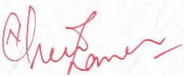  Naureen Zaman  Assistant Professor  English Language Unit  School of Education | 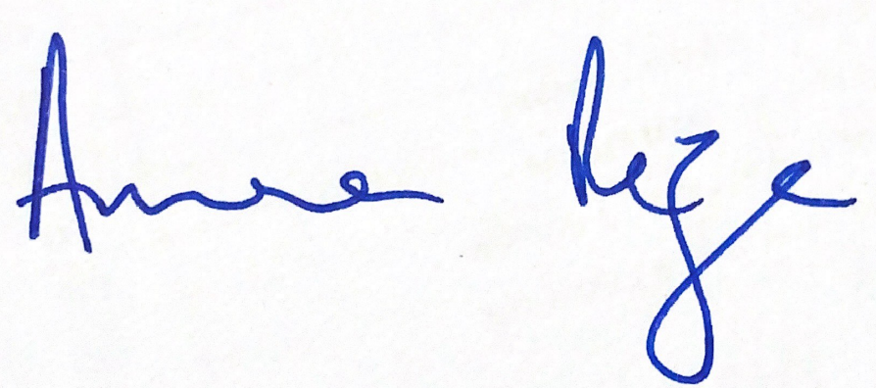  Prof. Dr. Amra Raza  Dean  School of Education

